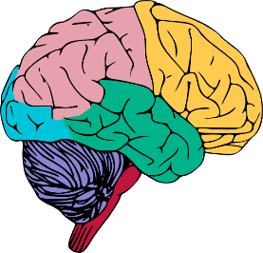
GATE Group Schedule 2015-16
Grade 1-2 at 12:00 Grade 4 at 2:00 Grade 3 at 2:30

“Our Amazing Brain”
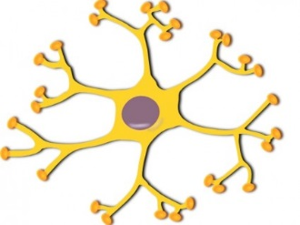
Friday, September 25
Friday, October 16
Friday, November 20
Friday, December 18
Friday, January 29
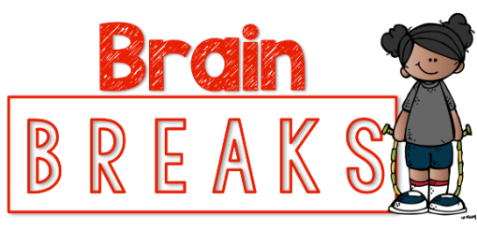
Friday, February 19
Friday, March 18
Friday, April 29
Friday, May 27

